- ANDROID NDK ALREADY HAVING llvm-readelf.exe file
- Need to convert the .apk file to .zip file, then extract it
- Find the .so files which are native files or indictor of libraries built with native code like c++ or android ndk.
- Use the following command to find the alignment that indicates the page memory size for the .so file whether it support 4 kb or 16 kb.
& "D:\AndroidStudioSDK\Sdk\ndk\29.0.14206865\toolchains\llvm\prebuilt\windows-x86_64\bin\llvm-readelf.exe" -l "D:\stc-work\project\ir-android\ir-mobile-android\app\release\aab_extract\universal_extracted\lib\arm64-v8a\libtoolchecker.so"
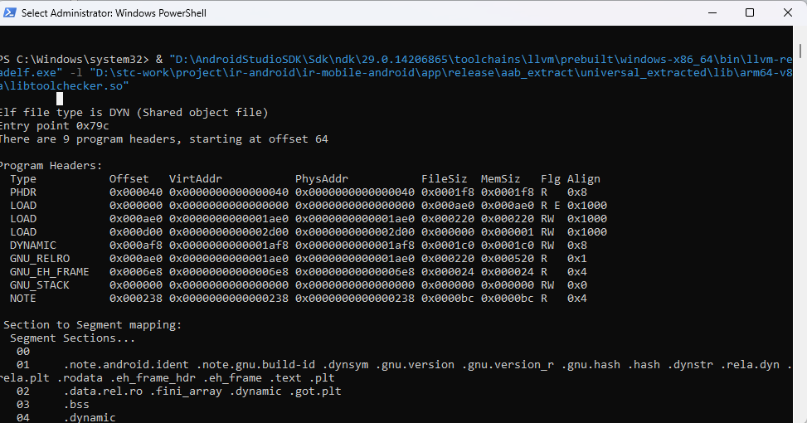
- The last file named libtoolchecker.so file’s memory page size is 0x1000 (4096 bytes). This comes from the Align column in front of the LOAD row. Which is valid for Android devices.
- If load segments in the Align column = 0x4000 or sometimes: p_align: 0x4000, so the ELF file’s memory page size is 16 KB.
- Here is a PowerShell script that Detect 16 KB Page-Size ELF Files:
  - Works on Windows
  - Uses llvm-readelf.exe from your Android NDK
  - cans all lib/**/arm64-v8a/*.so files
  - Flags any .so that requires 16 KB pages
# Path to llvm-readelf.exe
$readelf = "D:\AndroidStudioSDK\Sdk\ndk\29.0.14206865\toolchains\llvm\prebuilt\windows-x86_64\bin\llvm-readelf.exe"

# Path to llvm-readelf.exe
$readelf = "D:\AndroidStudioSDK\Sdk\ndk\29.0.14206865\toolchains\llvm\prebuilt\windows-x86_64\bin\llvm-readelf.exe"

# Root folder containing all lib folders
$libRoot = "D:\stc-work\project\ir-android\ir-mobile-android\app\release\aab_extract\universal_extracted\lib"
# Output report file
$reportFile = "D:\stc-work\scripts\so_page_size_report.txt"
# Clear previous report
if (Test-Path $reportFile) { Remove-Item $reportFile }
Write-Host "Scanning all .so files under $libRoot..." -ForegroundColor Cyan
Add-Content -Path $reportFile -Value "Scanning all .so files under $libRoot..."
# Counters
$total = 0
$count4KB = 0
$count16KB = 0
# Recursively get all .so files
Get-ChildItem -Path $libRoot -Recurse -Filter *.so | ForEach-Object {
$total++
$file = $_.FullName
# Run readelf on each .so file
$output = & $readelf -l $file
# Extract all Align values
$alignments = $output | Select-String -Pattern "Align"
$requires16KB = $false
foreach ($line in $alignments) {
if ($line -match "0x4000") {
$requires16KB = $true
break
}
}
if ($requires16KB) {
$msg = "[16KB] $file"
Write-Host $msg -ForegroundColor Red
$count16KB++
} else {
$msg = "[4KB] $file"
Write-Host $msg -ForegroundColor Green
$count4KB++
}
# Append to report file
Add-Content -Path $reportFile -Value $msg
}
# Summary
$summary = @"
`nScan Summary:
Total .so files scanned: $total
4 KB page size: $count4KB
16 KB page size: $count16KB
"@
Write-Host $summary -ForegroundColor Yellow
Add-Content -Path $reportFile -Value $summary
if ($count16KB -gt 0) {
Write-Host "⚠ Warning: Some .so files require 16 KB pages! This may cause issues on Android 14+ devices." -ForegroundColor Red
Add-Content -Path $reportFile -Value "⚠ Warning: Some .so files require 16 KB pages! This may cause issues on Android 14+ devices."
} else {
Write-Host "All .so files use 4 KB pages. No issues detected." -ForegroundColor Green
Add-Content -Path $reportFile -Value "All .so files use 4 KB pages. No issues detected."
}
Write-Host "`nReport saved to $reportFile" -ForegroundColor Cyan

Save the last script in a power shell script, with the extension .ps1 file format. And use the following command:
Cd to the location of the last power shell script.
Enter Set-ExecutionPolicy -Scope Process -ExecutionPolicy Bypass in power shell.
Enter .\check_so_page_size.ps1
Output is as follows:
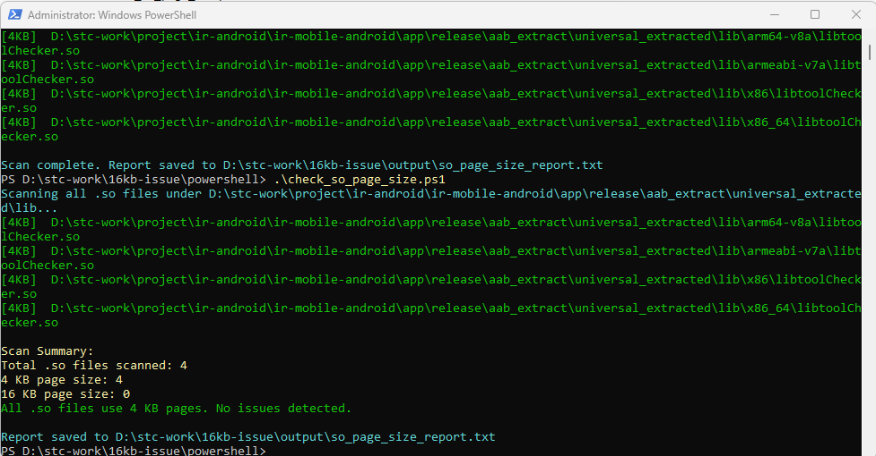
- A text report will be saved to the path in the last image.
- According to the last investigation , we could not find any .so files that are having 16 kb issue and needs to be resolved. We have to check other locations
Checked files :
lib/armeabi-v7a/*.so
lib/arm64-v8a/*.so
lib/x86/*.so
lib/x86_64/*.so
All 4 KB → fine.
- Other places to detect the .so files or native code in Android APK/AAB:
  - dynamic feature modules
  - embedded .dex or .bin files
  - bundled third-party libraries
- IF you want to analyze all the apk file from any files or libraries affecting the native code that causes memory page size issue use the following more-task complete script that can perform:
• Recursive scan of entire APK extract folder.
• Detects all .so files under lib/, assets/, or anywhere else.
• Detects .so files inside .jar and .aar archives.
• Checks page alignment with llvm-readelf -l.
• Prints colored logs for 4 KB (green) and 16 KB (red) memory page alignment.
• Outputs a report to the same path as previous (so_page_size_report.txt).
• Adds summary with counts and warnings.
• Detects .bin / .dat files (prints them as possible native code).
• Keeps existing features from your last script.
- The script is as follows:

# -------------------------------
# Configurations
# -------------------------------
$readelf = "D:\AndroidStudioSDK\Sdk\ndk\29.0.14206865\toolchains\llvm\prebuilt\windows-x86_64\bin\llvm-readelf.exe"
$apkExtractRoot = "D:\stc-work\project\ir-android\ir-mobile-android\app\release\aab_extract\universal_extracted"
$reportFile = "D:\stc-work\scripts\so_page_size_report.txt"
# Clear previous report
if (Test-Path $reportFile) { Remove-Item $reportFile }
Write-Host "Scanning entire APK extract folder..." -ForegroundColor Cyan
Add-Content -Path $reportFile -Value "Scanning entire APK extract folder: $apkExtractRoot"
# Counters
$total = 0
$count4KB = 0
$count16KB = 0
# -------------------------------
# Helper function: Check .so page alignment
# -------------------------------
function Check-SoFile {
param (
[string]$soPath,
[string]$parentArchive = ""
)
$global:total++
try {
$output = & $readelf -l $soPath
$alignments = $output | Select-String -Pattern "Align"
$requires16KB = $false
foreach ($line in $alignments) {
if ($line -match "0x4000") {
$requires16KB = $true
break
}
}
if ($requires16KB) {
$msg = if ($parentArchive -ne "") { "[16KB] $soPath (inside $parentArchive)" } else { "[16KB] $soPath" }
Write-Host $msg -ForegroundColor Red
$global:count16KB++
} else {
$msg = if ($parentArchive -ne "") { "[4KB] $soPath (inside $parentArchive)" } else { "[4KB] $soPath" }
Write-Host $msg -ForegroundColor Green
$global:count4KB++
}
Add-Content -Path $reportFile -Value $msg
} catch {
Write-Host "Error reading $soPath: $_" -ForegroundColor Yellow
Add-Content -Path $reportFile -Value "Error reading $soPath: $_"
}
}
# -------------------------------
# 1. Scan all .so files recursively in APK folder
# -------------------------------
Get-ChildItem -Path $apkExtractRoot -Recurse -Filter *.so | ForEach-Object {
Check-SoFile $_.FullName
}
# -------------------------------
# 2. Scan .so files inside .jar and .aar archives
# -------------------------------
Get-ChildItem -Path $apkExtractRoot -Recurse -Include *.jar, *.aar | ForEach-Object {
$archive = $_.FullName
Write-Host "`nProcessing archive: $archive" -ForegroundColor Cyan
Add-Content -Path $reportFile -Value "`nProcessing archive: $archive"
# Create a temporary folder for extraction
$tempDir = Join-Path $env:TEMP ("apk_temp_" + [System.Guid]::NewGuid().ToString())
New-Item -ItemType Directory -Path $tempDir | Out-Null
try {
Expand-Archive -LiteralPath $archive -DestinationPath $tempDir -Force

# Check for .so files inside extracted archive
Get-ChildItem -Path $tempDir -Recurse -Filter *.so | ForEach-Object {
Check-SoFile $_.FullName $archive
}
} catch {
Write-Host "Error extracting $archive: $_" -ForegroundColor Yellow
Add-Content -Path $reportFile -Value "Error extracting $archive: $_"
} finally {
# Clean up temporary folder
Remove-Item $tempDir -Recurse -Force
}
}
# -------------------------------
# 3. Optional: Detect potential native code inside assets/.bin/.dat files
# -------------------------------
Get-ChildItem -Path $apkExtractRoot -Recurse -Include *.bin, *.dat | ForEach-Object {
$file = $_.FullName
Add-Content -Path $reportFile -Value "Possible native content file: $file"
}
# -------------------------------
# 4. Summary
# -------------------------------
$summary = @"
`nScan Summary:
Total .so files scanned: $total
4 KB page size: $count4KB
16 KB page size: $count16KB
"@

Write-Host $summary -ForegroundColor Yellow
Add-Content -Path $reportFile -Value $summary

if ($count16KB -gt 0) {
Write-Host "⚠ Warning: Some .so files require 16 KB pages! This may cause issues on Android 14+ devices." -ForegroundColor Red
Add-Content -Path $reportFile -Value "⚠ Warning: Some .so files require 16 KB pages! This may cause issues on Android 14+ devices."
} else {
Write-Host "All .so files use 4 KB pages. No issues detected." -ForegroundColor Green
Add-Content -Path $reportFile -Value "All .so files use 4 KB pages. No issues detected."
}
Write-Host "`nReport saved to $reportFile" -ForegroundColor Cyan

